**ProEP**

**Chat application with Peer-To-Peer connection**

________________________________________________________________________

# 

# 

# 

# **End-User Manual for the Hybrid Application**

End-User Manual for the Hybrid Application

How to use our Hybrid Chat Application

1 - Launch the client

2 - Log In page

3 - The Chatroom

4 - Private Chat

Using a VPN : LogMeIn Hamachi

1 - Create an account

2 - Get the installer from your LogMeIn account

3 - Install Hamachi client

4 - Join a network with Hamachi

## How to use our Hybrid Chat Application

### 1 - Launch the client

Launch the **clientForm.exe** to run the application.

No install is required.

### 2 - Log In page

Enter your username inside the dedicated field and click on the **Login** button to get access to the server.

You username will be used to communicate, all other users will see you with this name.

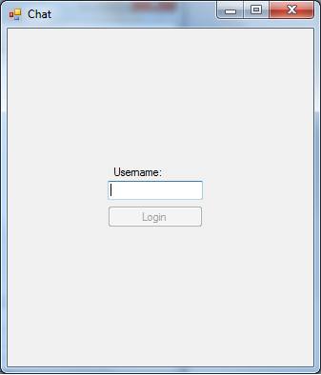

### 3 - The Chatroom

In the chatroom, you can see all previous messages users send here.

You can send a public message and participate to the talk.

Just write your text and click on the **Send** button to submit it to the chatroom.

You can have a private talk at the same time you’re chatting in the public chat.

Click on the name of the user you want to discuss with and a private conversation will be initiated with him (**Private Chat** tab).

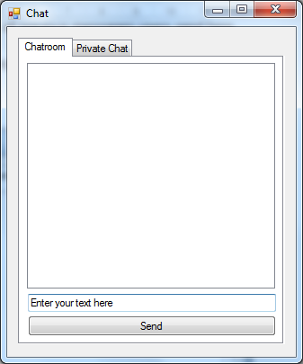

### 4 - Private Chat

In the Private Chat, a list of all users, with their status (**online** or **offline**), is displayed.

You can only chat with an online user.

To chat with someone, click on the user you want to chat with, and you’ll be able to see messages and send messages to that user. Enter your text in the field at the bottom and then click to the Send button.

If you click on a user in the **Chatroom** tab, the **Private Chat** will show the conversation you have with this user, or start a new conversation.

You can come back to the list of users by clicking on the **Back** button.

## Using a VPN : LogMeIn Hamachi

LogMeIn Hamachi provide a useful VPN that not require a lot of configuration and can be running very quickly, but require a LogMeIn account to work properly.

### 1 - Create an account

*If you already have a LogMeIn account, go straight to step 4*

Go to this website to create an account and download the necessary software :

<https://secure.logmein.com/products/hamachi/>



LogMeIn have two offers. We will use the free version because it can connect 5 people in the same time, it’s enough for a private utilization or pay it if you want more people to connect Click on **Try It Free** button to continue.

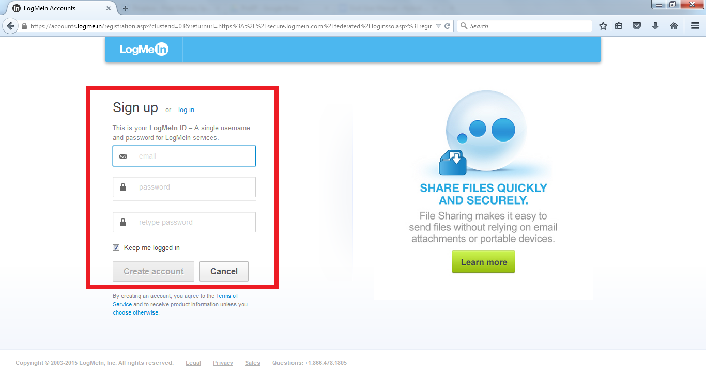

You have to create a LogMeIn account to use Hamachi.   
Once you enter all required information in this page and on the next one, you will be logged in ( but you have to go to the attach e-mail address to confirm your account).

### 2 - Get the installer from your LogMeIn account

In order to install hamachi and use it directly without any extra configuration, you have to download the installer that is linked to your account.

So on your LogMeIn account :

* On the left menu, go to **My Network**
* Click on the button **Add Client** to install Hamachi on your computer
* Select Install LogMeIn Hamachi on this computer   
  - Click on the **Download Now** button to start downloading the installer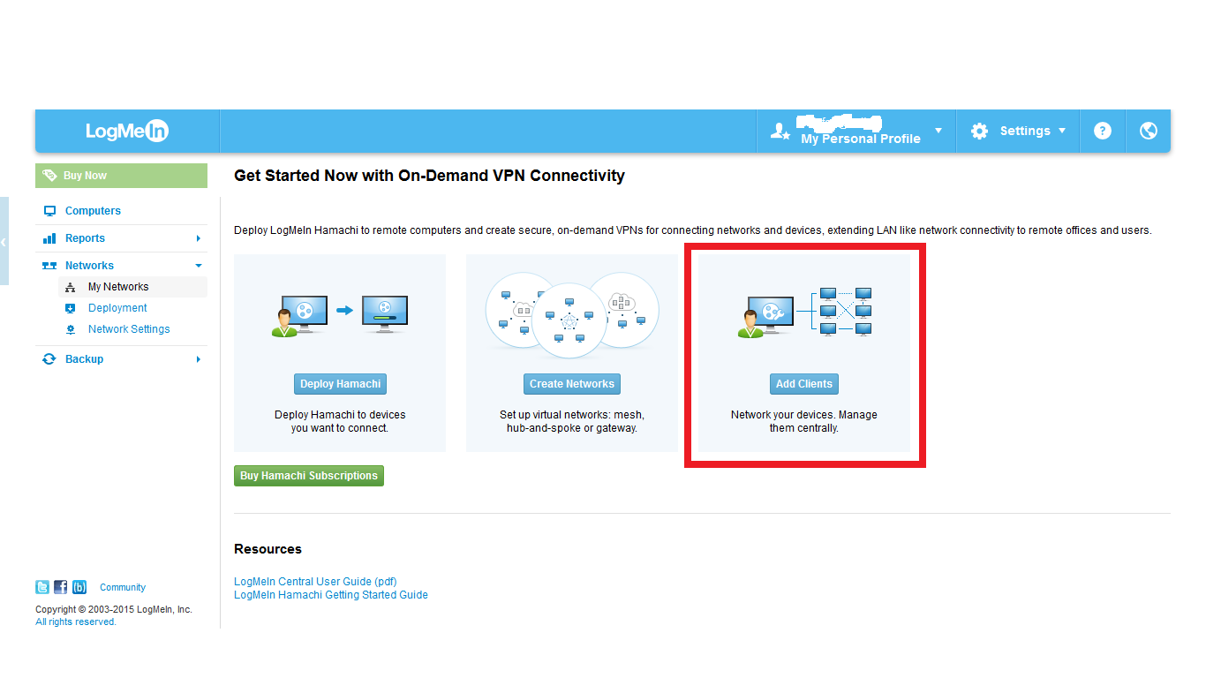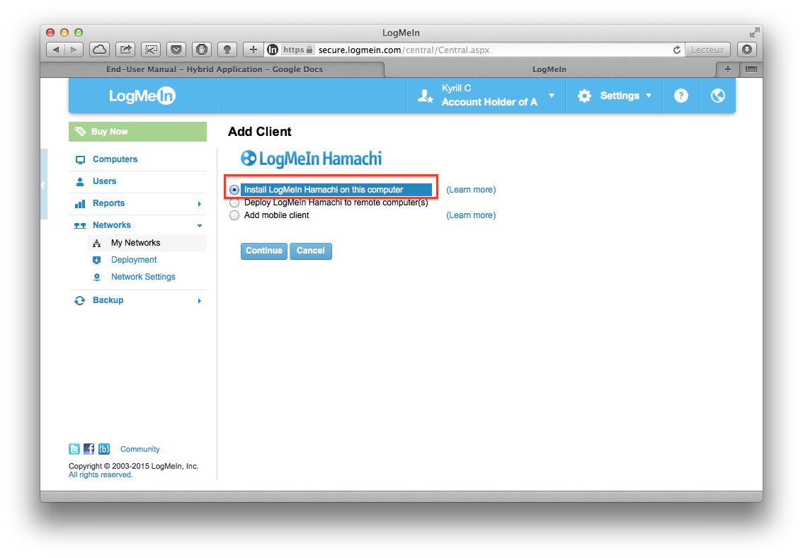

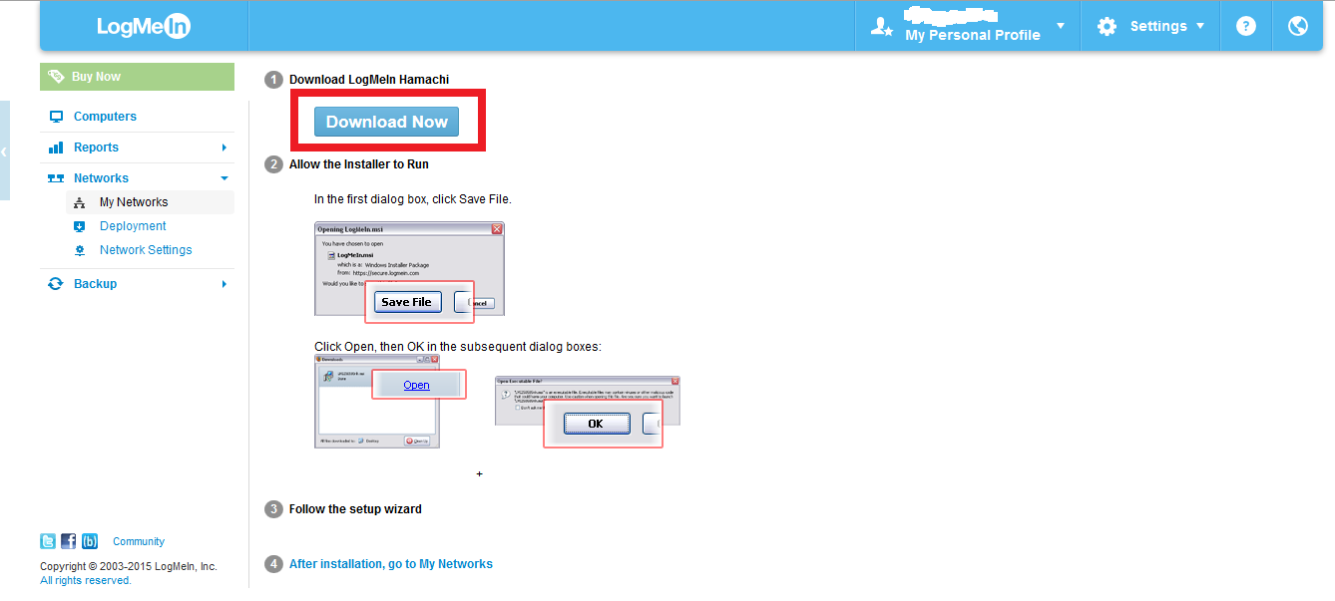

### 3 - Install Hamachi client

One the hamachi.msi is downloaded, launch it and follow the steps to the end.

Launch Hamachi when the install is finished.

### 4 - Join a network with Hamachi

The last step requires to know the name of the network on Hamachi. For example our network is named ProEP and had a password.

So you just have to click on **Join an existing network** and fill the fields requires to find this network.

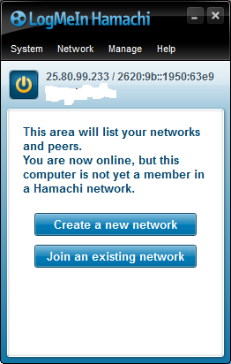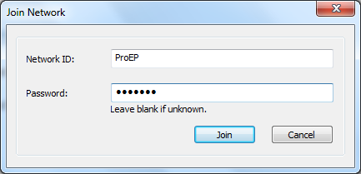

Congratulations !

You are connected to your private network and can use our Hybrid Chat Application !